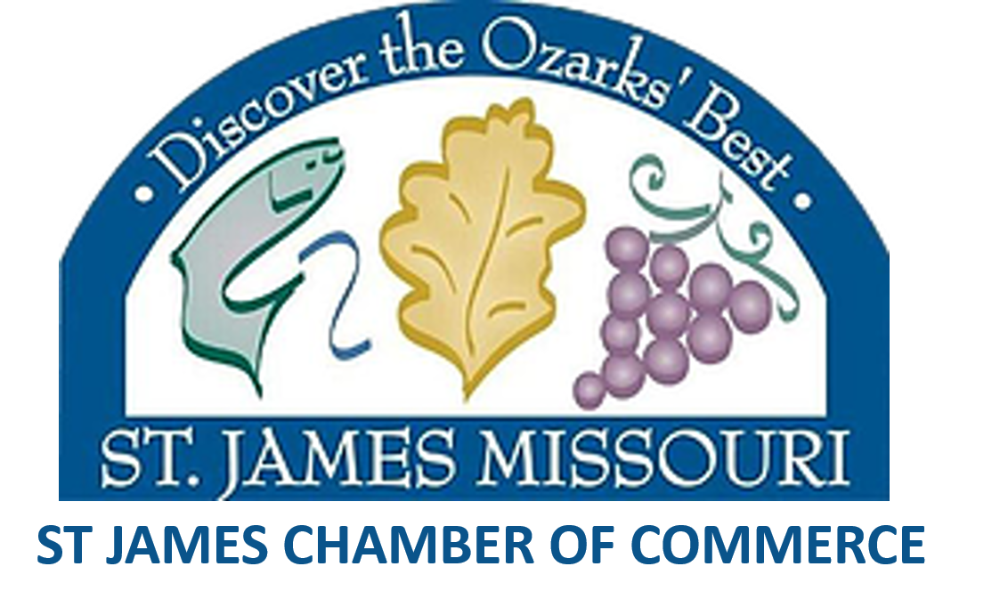

Membership Benefits

- Low Membership Fees
- Easy to find Online Chamber Directory
- Chamber Website Advertising
- Personalize Website or link to your website within our Chamber Website Directory
- Increased Social Media Exposure through the Chamber Facebook Page
- Preferred Brochure Placement at the Tourist Information Center
- Preferred Referral from Tourist Information/Chamber Employees
- Exclusive advertising opportunities to cost-share in high volume print brochures and articles.
- Exclusive sponsorship opportunities at numerous local events including but limited to: Opening Trout Day, Sip N Savor, Demo Derby, July 4th Fireworks, Annual Golf Tournament, Grape & Fall Festival
- Discount Vendor Fees at Grape & Fall Festival
- Exclusive Invite to Commerce & Cocktails Networking events
- Exclusive opportunity to host/ co-host a Commerce & Cocktails or provide a door prize.
- Exclusive Invitation to quarterly Chamber Luncheons for Networking and informational purposes.
- Ribbon-Cuttings with Press Coverage for new businesses, expansions and anniversary/milestones.
573-265-6649 / P.O. Box 358, St. James, MO 65559 / stjameschamber.net

